united states postal services
Application for Delivery of Mail Through Agent

PS Form 1583, December 2004
(7530-01-000-9365)

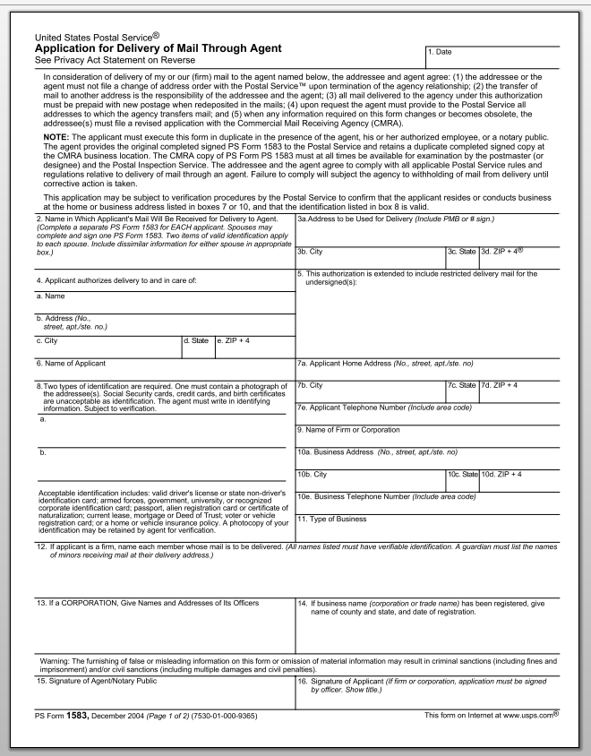

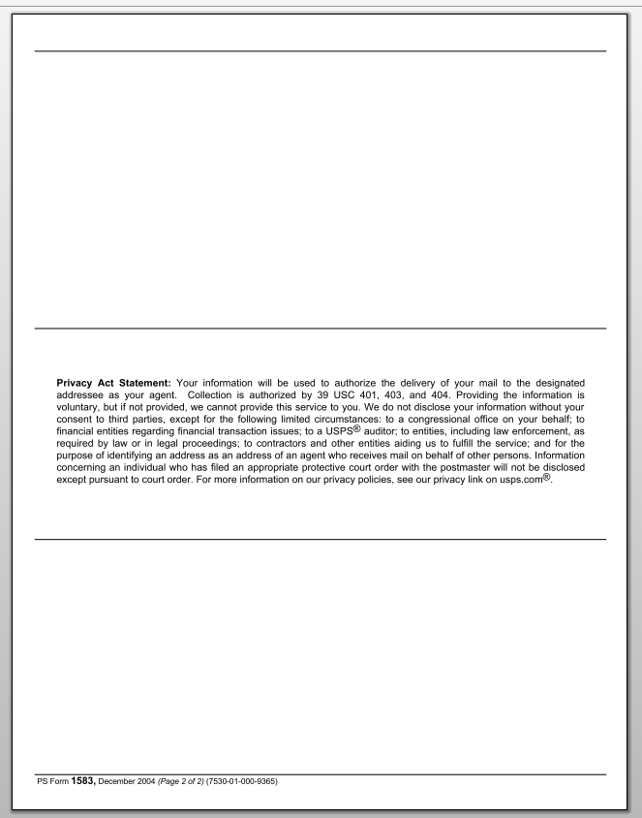

MAILBOX PLUS AND MORE, LLC.
Application for Delivery of Mail Through Agent

MAILBOX PLUS AND MORE, LLC.
Application for Delivery of Mail Through Agent

Mailbox Service Agreement Terms and Conditions
Mailbox Service Agreement Terms and Conditions Page 1

- This Mailbox Service Agreement (“Agreement”) is made and entered into by the customer identified on attached United States Postal Service Form 1583 (“Customer”) for the use of and services related to a mailbox (“Mailbox”) at Mail Box Plus and More, LLC, identified as the (“The Center”), under the terms forth herein.

- Customer must present a current valid ID, containing a picture, for identification purposes. Valid considered ID’s are a valid driver’s license, passport, passport card, alien registration card, or certificate of naturalization.

- Customer agrees that Customer will not use The Center premises or any Center services for any unlawful, illegitimate, or fraudulent purpose, or for any purpose prohibited by U.S. postal regulations. Customer further agrees that any use of the Mailbox shall be in conformity with all applicable federal, state, and local laws. Each Customer or entity must complete a United States Postal Service Form 1583 (“Form 1583”) to be authorized to receive mail or packages at the Mailbox.

- Possession of the Mailbox key shall be considered valid evidence that the possessor is duly authorized to remove any contents from the Mailbox. In the event of death or incapacity of Customer, The Center, will require the appropriate documents for the probate Court, the executor of the estate, the trustee or other similar person or entity before releasing mail or packages to a requesting party. If the Customer does not have a key in possession at the moment of retrieving the mail, The Center, will require a current valid photo to identify the owner or person authorized to pick up the mail.

- Customer agrees to pay an initial key deposit fee of $20.00. The key deposit will be refunded at the cancellation of this contract and upon returning the Mailbox key to The Center. If the Customer fails to return the key to The Center, The Center will keep the $10.00 key deposit fee. Customer agrees to pay a $20.00 fee for a Mailbox key duplicate in the event of a lost key.

- Customer agrees that The Center, may withhold mail and packages from Customer pending payments. The Center reserves the right to return any mail or packages to the sender if the Customer account is on arrears. An account is considered to be in arrears if no payment has been received for 30 days or more. The Center will charge a late fee of $10.00 to the Customer account, at the end of every month, if the Customer account has an open balance for more than 30 days. Customer Agrees to pay a onetime nonrefundable charge of $0.00 as a processing fee for opening a new mailbox. In Order to comply with regulations of the Fire Department and other Governmental Agencies, regarding the use of space in our Store and for the security of our Employees and all of our Customers, Mail Box Plus and More, LLC., beginning August 1, 2016, will only store any size package delivered to our Box Holders by USPS, FEDEX, DHL or UPS, for no more than 12 consecutive days., After the grace period of the 12 consecutive days, Customer agrees to pay a Package Pickup Delay Fee of $1.00, per Item and per day. The grace period will be calculated using the date on the Package Notification Slip. This measurement will allow us to keep our work environment safe, for everybody, leaving all the isles clear of packages, in case of an emergency. The Customer can have up to six (6) extra mailbox holders, per mailbox, at no extra cost.

- In the event that the Customer receives an unreasonable volume of mail or packages at the Mailbox according to the Center, reasonable judgement, the Center, may require the Customer to upgrade to a larger size Mailbox and pay an additional charge. The Center reserves the right to increase the Mailbox service fee in the event that Customer adds additional individuals or entities to names of those individuals or entities authorized to receive mail and packages at the Mailbox pursuant to Form 1583.

- This Agreement and Form 1583 shall remain confidential, except upon written request of any law enforcement or other governmental agency, or when legally mandated. Customer agrees to sign a revise version of this Agreement and Form 1583 whenever any information required on this Agreement or Form 1583 changes.

Mailbox Service Agreement Terms and Conditions Page 2

- Customer agrees that upon expiration, cancellation, or termination of this agreement, Customer will no longer be able to use the mailbox address, at The Center. Customer agrees that upon expiration, cancellation, or termination of this agreement, Customer authorizes The Center to accept and destroy any “Unsolicited Mail” (e.g., mail address to “Occupant”, “Current Resident”, or similar designation, or coupons, advertising, or other promotional material) and any mail addressed to Customer that is delivered to The Center by the United State Postal Service and may refuse any package addressed to the Customer delivered by any party other that the United State Postal Service, such as a commercial carrier service. However, at Customer’s election, the Center will:

- Re-mail (i.e., forward) Customer’s mail (except for Unsolicited Mail) for six (6) month upon Customer’s payment for postage, packaging material and forwarding fees. It is the Customer responsibility to make arrangements with the Center to identify any mail forwarding needs prior to the expiration, cancellation, or termination of this agreement. Customer will sign an application requesting this service.

- Store the mail or United States Postal Service packages (except Unsolicited Mail) for up to six (6) month upon Customer’s payment, in advance, of a storage fee of $162.00, in which the Center holds the mail or packages. It is Customer’s responsibility to make arrangements with The Center to identify any mail storage needs prior to the expiration, cancellation, or termination of this Agreement. Customer will sign an application requesting this service.

- The Center reserves the right to cancel, terminate, or sell this Agreement at any particular moment. The Center will notify the Customer immediately of the decision to cancel, terminate, or sell this agreement. At the time of this Agreement cancelation, termination, or selling, the Center and the Customer will make new arrangements to manage the Customer mail. The Customer agrees to pay a delay charge of $10.00, every month, for unpaid balances
with more than 30 days.

- The Customer has the option to:

11a. Prepaid six (6) month in advance for a mailbox at a rate of $27.00 per month.
Customer initials to accept option 11a. _________.

11b. Prepay twelve (12) month in advance for a Mailbox at a rate of $27.00 per month.
Customer initials to accept option 11b. ___________.

11c. Prepaid a three (3) month in advance for a Mailbox at a rate of $27.00 per month.
Customer Initials to accept option 11c. ___________.

11d. Authorize any future charges for future rendered services at the Center.
Customer initials to accept option 11d. ____________.

Mailbox Service Agreement Terms and Conditions Page 3

- By initialing and signing below, the Customer, establishes automatic renewal payments or automatic monthly payments at The Center. The Customer authorizes The Center to charge to his credit card the amount of the designated mailbox size per The Center pricing on the schedule interval that the Customer has selected on clause 11. If the Customer provides an e-mail address, the Customer understands that will receive an email notification of the payment transaction, otherwise, Customer will receive a payment notification on the mailbox. The Customer understands that if the payment cannot be transacted due to incorrect or obsolete payment information or the transaction would exceed the credit limit of the amount, or the bank, or credit card company rejects/returns the payment request, the Customer Mailbox may be closed and any mail received after closure would be returned to the sender. If the Customer mailbox is closed for nonpayment, the Customer understands that a late payment fee will be charged and added to the Customer account, for every month that the Center has not received the monthly fee associated with the Mailbox or to reactivate the Customer mailbox. The Customer agrees to inform The Center of any changes to the Customer credit card number, billing address, or expiration date or any other information that may affect the availability to make charges to the Customer credit card. The Customer understands that this automatic renewal payment or automatic monthly payment will remain in effect until the Customer or the Center terminates the mailbox service Agreement. The Center may terminate the Customer participation under this automatic payment agreement in the event the Customer provides incorrect, false, or fraudulent account information or if the Customer has any returned payments items. If the Customer decides not to use the automatic renewal clause, the Customer will not be entitled to any prepayment discounts and the Customer account will be charge in a monthly basis accordingly to the mailbox rate selected.

Mailbox Service Agreement Terms and Conditions Page 4

Customer Initials ________ ( ) Auto Renewal ( ) Auto Monthly Payments ( ) Future Service Fees

Name on Credit Card ________________________________CC Security Code ___________________

Credit Card # ______________________________________ Credit Card Type ____________________

Credit Card Billing Address ______________________________________________________________

City/Province __________________________, State/Country ____________ Zip Code ______________

Customer Authorization Signature ______________________________ Exp. Date _________________

- Mailbox service agreement certification:

I, the Customer, certify that all the information furnished on this Agreement is accurate, trustful, and complete.
The Customer understands that anyone who furnishes false or misleading information on this agreement or omits
information requested on this Agreement may be subject to criminal and/or civil penalties, including fines and/or
Imprisonment.

___________________________ _____________________________
Customer Signature Date

___________________________ ____________________________
The Center Authorized Signature Date
End of Application

